**Objective:** After completion of this unit, you should be able to demonstrate the proper use of the oscilloscope and all the test equipment on the bench, explain the purpose and proper use of each control and terminal. Set your equipment to generate a given signal, and make correct measurements.

**References:**

1. [Tektronix Oscilloscope Basic Concepts](https://elearn.isu.edu/moodle/pluginfile.php/3386527/mod_folder/content/0/Tektronix%20XYZs%20of%20Analog%20and%20Digital%20Oscilloscopes.pdf?forcedownload=1)
2. [Tektronix TDS Oscilloscope User Manual](https://elearn.isu.edu/moodle/pluginfile.php/3386527/mod_folder/content/0/Tektronix%20TDS2024%20Oscilloscope.PDF?forcedownload=1)
3. [Tektronix AFG1022 User Manual](https://elearn.isu.edu/moodle/pluginfile.php/3386527/mod_folder/content/0/AFG1022-Quick-Start-User-Manual-EN.pdf?forcedownload=1)
4. [Heath Sine-Square wave generator](https://elearn.isu.edu/moodle/pluginfile.php/3386527/mod_folder/content/0/SG-5218%20Sine-Square%20Audio%20Generator.pdf?forcedownload=1)
5. [Tektronix Technique brief (Lissajous Function)](https://elearn.isu.edu/moodle/pluginfile.php/3386527/mod_folder/content/0/Technique%20Brief.pdf?forcedownload=1)
6. [INSTEK DC power supply](https://elearn.isu.edu/moodle/pluginfile.php/3386527/mod_folder/content/0/DC%20Power%20Supply.pdf?forcedownload=1)

**Objectives:**

1. Show an image of the front panel of the oscilloscope. Label each control, input and output terminals if applicable. Briefly explain the function of each button and control on the scope (Specifically what menus are found under each button or control).
2. List the bandwidth specification for the oscilloscope and probes. Explain what bandwidth is and why it is important.
3. Explain what triggering is and draw a graph that shows the difference between a triggered and a free-running sweep.
4. Set the oscilloscope to trigger on the Probe Compensation Signal generated by the Oscope. Demonstrate the difference between free-running and triggered by adjusting the trigger level. Identify trigger: level, rise/fall, and trigger point. Document the procedure in your lab book and discuss why this is important. **VERIFY WITH YOUR INSTRUCTOR (1a, 1b).**
5. Explain and show how to properly compensate the low capacitance probes **VERIFY WITH YOUR INSTRUCTOR (2)**. Compensate all of your scope probes. Check your probes to ensure they are functioning properly. You will need all of them this semester. Report and problems to your instructor, or the lab assistant.
6. Verify the calibration of the vertical amplifiers (Volts/Div Control)

|  |  |
| --- | --- |
| DC Supply Setting: | Volts/Div Control: |
| 1VDC | 200mV/Div |
| 1VDC | 500mV/Div |
| 1VDC | 1V/Div |
| 10VDC | 2V/Div |
| 10VDC | 5V/Div |
| 10VDC | 10V/Div |
| 50VDC | 10V/Div |
| 50VDC | 20V/Div |
| 50VDC | 50V/Div |

Document how you did this in your lab book. Report any problems to your instructor or lab assistant.

1. Verify the calibration of the horizontal amplifiers (Time/Div). Develop a test set similar to step 6. Document how you did this in your lab book. Report any problems to your instructor or lab assistant.
2. Demonstrate and document the three measurement methods for measuring frequency and amplitude. Compare results in a table and explain any discrepancies. **VERIFY WITH YOUR INSTRUCTOR (3a-3d)**
   1. Measurements using Graticules
   2. Measurements using Cursor Function
   3. Measurements using Auto Measure
3. Measure and record the rise and fall time of a 100kHz square wave from the Heath Sine-Square Audio Generator. Verify the values meet the manufacturer’s specifications.
4. 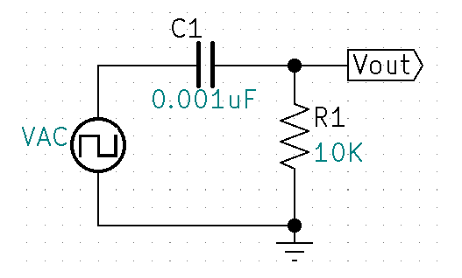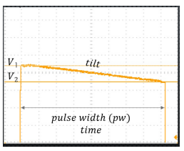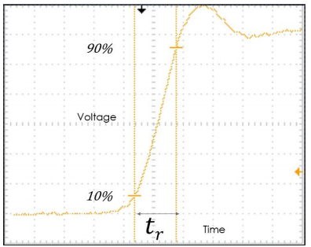Construct the following circuit. Measure the tilt and rise time at 100Khz. **VERIFY WITH YOUR IN** **STRUCTOR (4)**.
$Frational Tilt= \frac{V1-V2}{APA} OR \frac{∆V}{Vav}$

5. 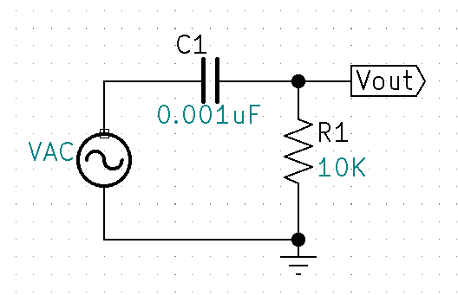For the following circuit, Calculate output voltages at the cutoff frequency and the passband. Draw calculated bode plot and waveforms at both passband frequencies and cutoff frequencies, Include phase angles. Measure the circuit and compare to the predicted values. Explain any discrepancies. **VERIFY WITH INSTRUCTOR** **(5a-5c).**
6. Reference the Tektronix Lissajous document and draw Lissajous patterns in your lab book at 0° 360°, 45° 225°, 90° 270°, 135° 315°, 180°. Document procedure to calculate phase based on Lissajous pattern. Connect the AFG1022 Ch1 and Ch2 outputs to Oscope Ch1 and Ch2. Set up the generator so both signals are the same frequency, amplitude and phase. Observe and document the Lissajous pattern on the Oscope. Adjust the signal phase 45° of one of the signals at the generator. Observe and document the Lissajous pattern. Repeat the process to verify 90°, 135°, and 180° and compare with predicted Lissajous patterns. **VERIFY WITH INSTRUCTOR** **(6a, 6b).**
7. Predict Lissajous pattern for output compared to the generator at critical frequency for the circuit in step 11. Measure and note any discrepancies. **VERIFY WITH INSTRUCTOR** **(6c).**
8. Complete Conclusion and submit completed Check-Off sheet and Lab writeup in Moodle.